This will be a guide on how to set up the raspberry pi pulse sensor. Instructions are also available online

All wires are male to female unless stated otherwise

Step one: put the back left leg of the MCP3008 - 8 Channel 10-Bit ADC with SPI interface into e6 and the back right into the f6. The front two go into the e and f 13

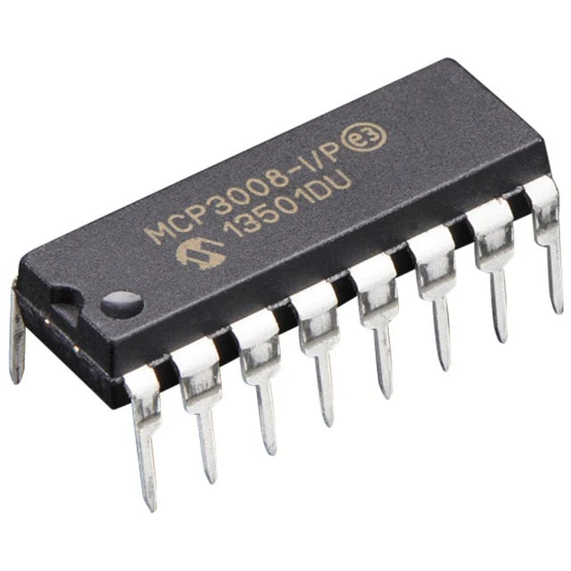

back

front

Step 2: place a wire in a7 and and the other end 12 down on the right side of the pi

Step 3: place a wire from a8 to 10 down on the left

Step 4: place a wire from a9 to 11down in the left

Step 5: place a wire from a 10 to 12 down on the left

Step 6: place a wire a 6 to negative 5

Step 7: place a wire from a 11 to negative 11

Step 8: place a wire from a 12 to positive 13

Step 9: place a wire from a 13 to positive 14

Step 10: put the negative wire of your sencor into g 13

Step 11: put the ground wire of the sensor into negative 2

Step 12: put the positive wire of the sensor into the first part on the left of the pi

